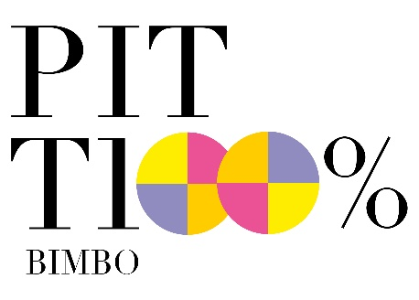

I WANT TO BE GREEN
The special project dedicated to responsible kidswear.
Pitti Bimbo puts the spotlight on collections and initiatives
in line with the “eco-conscious” drive of the new generations..

Focus on sustainability, with brands based on conscious stances and those that revised their processes according to an eco-friendly perspective. I Want to be Green is the special project that Pitti Bimbo dedicates to the collections and initiatives that make kidswear in line with the “eco-conscious” drive of the new generations. It includes a series of editorial content on Connect and a calendar of talks with the protagonists of green fashion; the project is coordinated by Dimitra Zavakou of Little Pop Up.
On the sustainability front, there is also the capsule collection made by Naturino in collaboration with Cuoio di Toscana, the association bringing together sustainable tanneries in the region.

Here is the calendar of talks scheduled at the UniCredit Theater
(Central Pavillion – Lower Floor):
_1 July, 4pm: Is the Future of Fashion Sustainable?
Featuring brands and buyers already taking a stand for sustainability: with Barbara Mezzanotte, owner of Mezzanotte Store; Claus Nielsen, Global Sales Manager of Bobux; and Salina Ferretti, CEO of Falc.

_2 July, 11am: Can Fashion be Sustainable and still Fashionable?
In conversation with buyers and brands about fashion choices and sustainable choices.
With Shana Laub, owner of Shana and Toad; Sara Bandinelli, Head of Global PR & Communication of Miniconf; Dinie Van Den Heuvel, Creative Director of Infantium Victoria.

Florence, 30 June 2021

