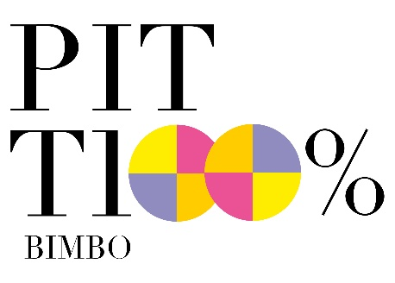

THE PITTI BIMBO EDITORIALS

Fashion editor Maria Giulia Pieroni takes us on an exciting exploration of the kids’ lifestyle universe. Sustainability and dinosaurs: these are the themes chosen for this edition to present objects, furnishings, and toys for the bedroom and the outdoors.

Editorials #1
Dinosaurs, forever friends

Dinosaurs are not scary, quite the opposite! They can be great friends: charming, extraordinary, mythical, and ironic. Bulky but familiar silhouettes, a bit clumsy but in a funny way, inhabit the bedrooms and are happy to be taken for a walk. A neverending bond between children and the Jurassic past that the first Editorial of this edition illustrates through a series of brands selected by Maria Giulia Pieroni, fashion & lifestyle editor (@LaPieroni_).

The brands:
Affenzahn, Dinoski, Djeco, Donkey, Esnaf Toys, Kiddimoto, L'Ippocampo, Little Lights, Meri Meri, Mushie, N°74, Pirouette Cacahouete, Plantoys, Pop By Gaea, Poppik, Seletti, Slipstop, Suck Uk, Trixie (Connect), Tutete, Wild & Soft.

Editorials #2
100% Sustainable

Natural materials, alternative productions, traceability, ethical values, and respect for children, nature, and the environment. Small steps for a meaningful vision that involves the wardrobe, as well as the lifestyle and accessories. Something beautiful that carries an extra value within – that of tomorrow. Follow us in this second episode of the Editorials series, curate by Maria Giulia Pieroni, fashion & lifestyle editor (@LaPieroni_).

The brands:
24Bottles Kids, A4ADesign, BabyLodge®, Bubble&Co, Cocomat Bike, Collégien, Danhera Italy,Ekoala, Franck&Fischer, L'Ippocampo, Koko Cardboards, Mini Kyomo, Oli&Carol, Picinìn Design, Qurkies, Plantoys, Sekkei Design sostenibile, Studio delle Alpi, Supernovas, Tutete.

